Our week has been yet another busy one with our Year Six pupils working tirelessly through their SATs papers. We are very proud of how they have approached these tests calmly and without unnecessary anxiety. The children had a lovely visit from Fleetwood Town FC and our older pupils have heard all about Belgium.
Running club began this week with 16 keen runners.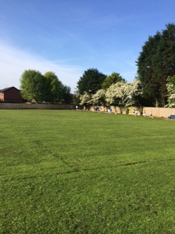 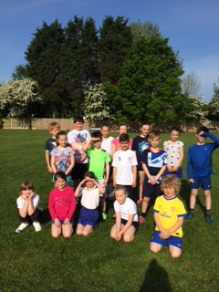The sun was shining and we were able to fully appreciate our stunning surroundings. It was a great start to our day. The children came in their sports wear equipped with drinks however; if it is wet we might also need spare socks and underwear bringing too!
Well done to Eagles and Parrots for having 100% attendance this week! It was also really lovely to hear from our visiting specialist gymnastic teacher that our pupils in Robins worked really well in their gymnastic session and that she reported that they are the best class of children she gets to work with over her week. I would like to welcome Oliver Brady to our school. He has joined our delightful Green Ducklings this week and has settled really well.

Pease continue to send your child in with a record of their achievements for Tuesdays.

Dates for your Diary
Dizzy Heights – Sat 24th May The Marine Hall Gardens are holding an exciting day of events from noon until 5pm.
Comenius Visit to Belgium  All travellers have returned safe and sound. We are to hold a Comenius Day on our return from the half term break. Letters are on their way to you with further details. Our scarecrow is now dressed in the clothing provided by each partner school. Details of our Comenius Club will be coming soon.
PTFA – Thank you to those of you that attended our most recent meeting. The arrangements for our Summer Fair on 5th July were discussed. If you are able to offer your services with any behind the scenes preparations, setting up on the day from 9:00am or are able to help run a stall in the afternoon please let the office know. We would most appreciate some volunteers for ‘Beat the Goalie’. The school has a gazebo but would welcome any additional to help fend off the strong rays of sunshine we are hoping for. If you are able to offer us the use of your gazebo, again please bob into the office to let us know.
Donations for Blackpool Soup Kitchen – During the week beginning the 19th May we are asking whether you could kindly donate a packet of dried food for the soup kitchen in Blackpool. If you feel this is something you would like to contribute towards please send your child in with the food to be handed into their classteacher.
Marine Conservation Roadshow – We have invited the roadshow to come to Carleton Green to talk with our children about how to best preserve marine life on the 21st May.
(Reminder)Best of British Lunch – Friday 23rd May.
(Menu – beefburger with salad and chips or fish, chips and peas, followed by apple pie and ice cream or shortbread biscuits.)
Back at school – Tuesday 3rd June 9:00am start. (Comenius Day!)

Clubs –
Tennis for year 3 and 4 – Tuesdays 15:30 – 16:30
Fencing – Wednesdays starting at 8:00
Cricket for Years 5 & 6 – Wednesdays 15:30 – 16:30
Choir – Thursdays at 15:30 – 16:15
Girl’s Football for Years 4, 5 & 6 – Thursdays at 15:30 – 16:15
Running club Year 2 upwards – Fridays starting at 8:10

We would like to say a huge well done to the children that have been selected for this week’s Star of the Week. 
Kaysha Ryan from Yellow Ducklings Oliver Brady from Green Ducklings
Jake Ramsden from Parrots Ben Middleton from Herons
Joe Preston from Robins Heny Offord from Owls
Reuben Perry from Doves Reuben Peacock from Kestrels
Libby Winston from Hawks All our Year 6’s for their wonderful effort this week.
Other Notices:
Please ensure that your child’s clothing is labeled with their name as uniform can be misplaced during a school day and we would not like you to lose your belongings. Also if your child wears earrings please either remove them for the day when they are to participate in a sport activity or provide some medical tape. As always please speak with your class teacher at the end of the day if you have any concerns or wish to share any information with us. Thank you.

