The Year Five children had a fabulous time at Winmarleigh. Thank you for the assistance with transporting to and from the outdoor centre. I would also like to extend a large thank you to all the staff that supported the activities over the weekend. Although this week has seen a lot of wet playtimes we have managed to enjoy the lunchtime activities set up by Fleetwood Town.
Our Mothers’ Day events have been a success and the cake decorating afternoon went very well. It was lovely that so many of you managed to come and attend these sessions and I am very grateful for the efforts of the PTFA too where these events raised £470.00 for the school.
The running club made a fabulous effort although the session made for a wet and muddy start to the day on Friday. Spending time on a Friday morning with such happy and enthusiastic children is the highlight of my week. However, please be mindful that this is an outdoor club whatever the conditions so it would be great if you could send your child into school with a towel as well as a full change of clothing.
We have enjoyed our “Dress up or dress down” day today and have raised a fantastic £321.50 for Comic Relief. We would like to thank Miss Holland, for kindly coming in from Sainsbury’s to sell Red Noses and other Comic Relief goodies and this helped to raise a further £297!
Blackpool Aquatics Swimming Club are currently looking for Boys/Girls aged 7-9. Must be able to swim 2 recognisable strokes for 25m (stage 4/5 in swimming lessons) Swimming trials are held on Friday evenings 7pm at Moor Park Pool Sunday afternoon Palatine Pool 4pm Please ask for Jane Whittle who will be on the poolside.
For more details please see the clubs website www.blackpoolaquatics.co.uk

Fylde Coast YMCA are running a FREE Children’s Nutrition and Physical Activity Programme called MEND (Mind Exercise Nutrition Do It) in partnership with Lancashire County Council. The Programme is for children aged between 7-13 who are above a healthy weight and their families. It is an 8 week programme which includes nutritional information as well as fun exercise sessions. Parents/carers and siblings also attend the programme with the children for a family approach to a healthier lifestyle.

The previous programmes have been very successful with children seeing a reduction in their Body Mass Index, reduction in waist circumference, increased fitness level, increased self-esteem and body confidence scores as well as parents reporting improved dietary balance, portion sizes and nutritional understanding.
Millfield High School, Belvedere Road, Thornton-Cleveley’s, FY5 5DG
Tuesday & Thursday 4.00pm – 6.00pm Starting Tuesday 21st April 2015
The programme is fully funded by LCC so there will be no cost at all to the families who sign up for the programme. Each place is valued at £400 so the families must be willing to commit to the 8 weeks.

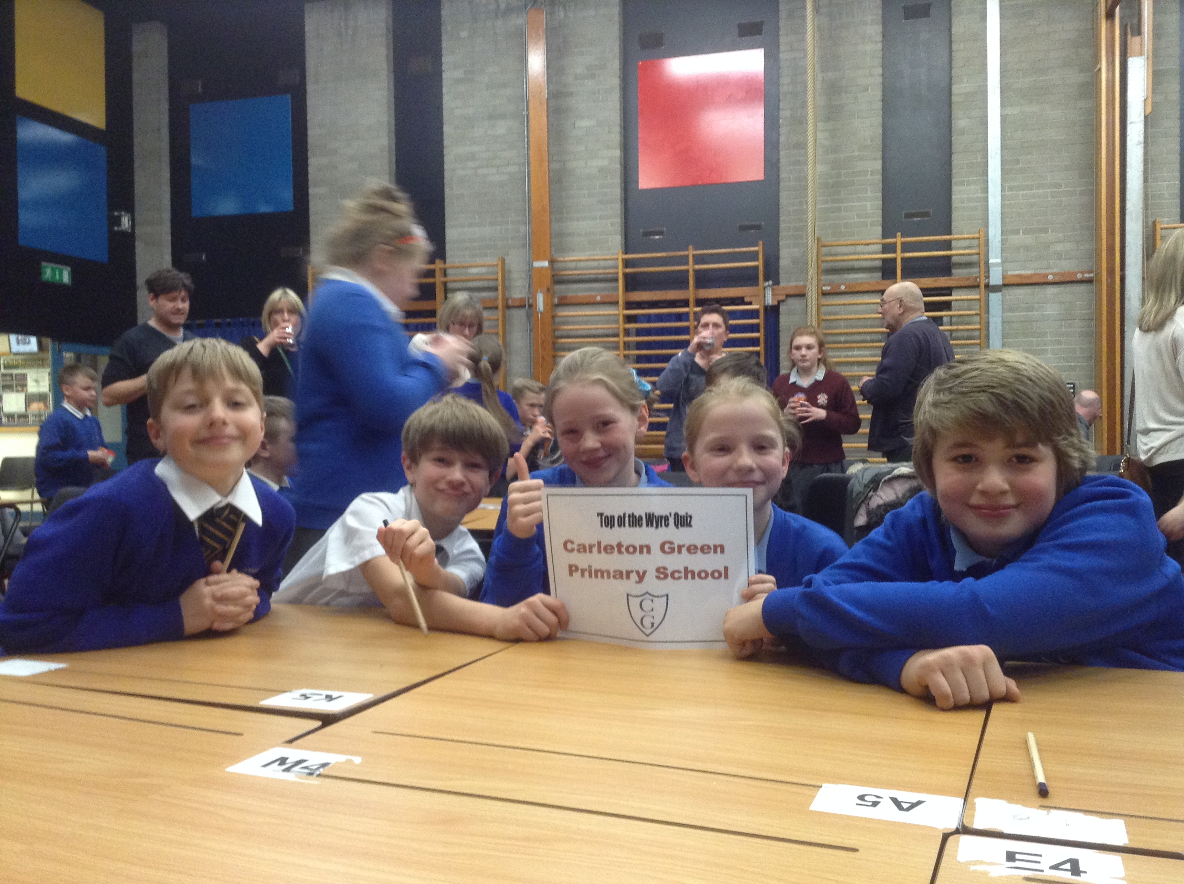

Miss Deane took a group of Year 5 pupils to Millfield last night. She would like to say a massive well done to all the children who took part in Top of the Wyre Quiz last night at Millfield Science and Performing Arts College (Lauren Merricks, Matthew Taylor, Sophia Parker, Ruben Perry and Charlie King). They worked fantastically as a team, demonstrated much enthusiasm and all brought their own subject specialties which helped gain valuable points.

Up and coming events:
Tuesday 17th March ~ Robins’ Class Assembly. All family members are welcome to attend this event that will start at 15:00.
Thursday 19th March Easter Disco This date has been moved forward by a week.
5pm to 6pm for reception and ks1 and 6.15pm to 7.30pm for ks2.
Entry is £1, hot dogs available for £1 together with drinks and sweets available to purchase. Volunteers to help will be greatly appreciated!!

Friday 20th March – Shooting Star books are to be sent home with the mid term reports and next steps of learning.
Tuesday 24th March and Wednesday 25th March - Parents’ Evenings from 15:45 – 18:00. All parents attending will be asked to enter and exit the school building through the main entrance rather than gaining access through our many doors. Booking slips for these evenings can be found at the bottom of this newsletter. I am sorry to cause any incovenience to the parents of children in Mrs Harding’s class but she will be available only on the Tuesday evening as she is supporting the Netball players whilst they compete in a tournament.
Easter Egg competition – either colour in or design your own Easter Egg. Details can be found added onto this newsletter.
Year 3 and 4 Production – Thursday 26th March. There will be two performances. A daytime performance starting at 14:00 and an evening performance starting at 18:00. Tickets for this event will be made available next week.
Friday 27th March ~ Finish for Easter 14:30
Easter Holiday Club Fleetwood Town will once again be running a Sports Club during the Easter break at school. Dates to be confirmed.
Dates for the summer term which is by no means exhaustive so look out for additional dates!
23rd April ~ Pay it Forward Day 
7th May ~ New Induction Evening
22nd May ~ break up for the holidays
2nd June ~ Back to school.
Week beginning the 8th June will be Healthy Living Week. More details will follow.
10th June ~ Scooter Day 
11th June ~ Sports’ Day for Juniors and Infants from 13:00
19th June ~ Non- uniform day (Bring an item for the Summer Fair)
26th June ~ Summer Fair 15:30-19:00 
Week beginning 6th July ~ Year Six Camp 
Week beginning 20th July ~ Leavers Events
22nd July ~ School closes at 14:30 for the summer holidays.

Star of the Week certificates this week and last week:
Jessica Williams and Callen Ormand  from Yellow Ducklings. | Nicholas Eaton and Thomas Dean  from Green Ducklings.
Freya Lee and Olivia Popielarska  from Parrots | Esmae Randall and Lola Panther  from Herons
Kitty Eliffe and Natalie Michelback  from Robins | Ryan Hurren and Pushkar Shanbhag  from Owls
Keisha Rigby and Lily Wilkinson  from Doves | Cole Butler and Freja Fields  from Kestrels
Sasha Crystal and Bethany Bradford  from Hawks | Lilly Sue Brade and Adam Bagshaw  from Falcons
Ruben Perry and Oliver Hey  from Eagles | Well done everyone!

Parents’ Evening Appointments:
Please tick the most suitable times on the night you are able to attend and send into school asap.
Tuesday 24th March | Wednesday 25th March
16:00-16:30 | 16:00-16:30
16:30-17:00 | 16:30-17:00
17:00 – 17:30 | 17:00 – 17:30
17:30-18:00 | 17:30-18:00
18:30-19:00 | 18:30-19:00
Name of child: | Class:


