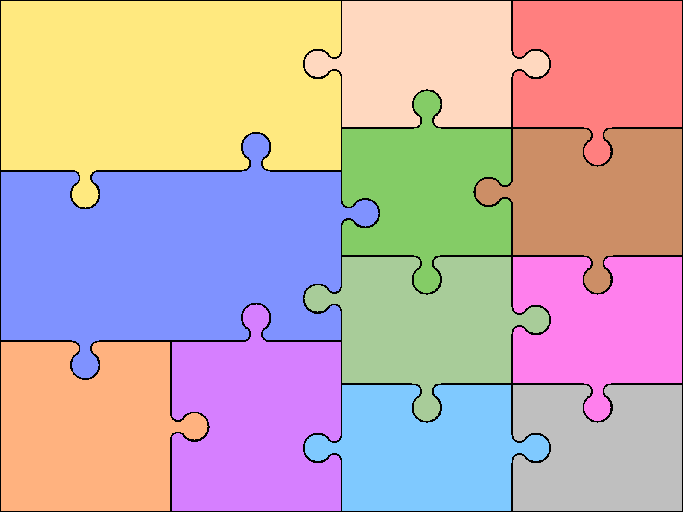

**ENGLISH**

**We will be writing diaries, letters, information texts & shape poems.**

**We will continue to focus on writing with capital letters, full stops & finger spaces. We will be learning how to use the suffix –ed, the past tense, commas in a list & generating verbs.**

**In guided reading, we will be learning to self-correct when the text doesn’t make sense. We will make inferences about events & characters.**

**HISTORY**

**We will read the Great Fire of London & find out how people’s lives then were different to ours now.**

**SCIENCE**

**We will learn explore the properties of materials & consider their uses. We will compare materials which were used during the time of the Great Fire & materials used now.**

***ROBINS’ CURRICULUM JIGSAW – AUTUMN 2 2018***

***Fire! Fire!***

**ART**

We will make fire pictures & black out silhouettes. We will create pictures using the style of our class artist, pointillism.

**PSHE**

**We will be talking about money sense & enterprise, anti-bullying & people who help us.**

**GEOGRAPHY**

This term we will look at the map of the UK to find Blackpool in relation to London. We will find out how & why London has changed.

**MATHEMATICS**

**We will be developing our multiplication & division skills.**

**We will be securing number bond knowledge for numbers to 20.**

**We will be learning the 2x, 5x & 10x tables.**

**We will continue to use place value, addition & subtraction skills & knowledge of 2D & 3D shape in morning maths.**

**PHYSICAL EDUCATION**

**Dance**

**We will develop our dance skills to perform to the music we have listened to.**

**DESIGN & TECHNOLOGY**

We will build Tudor houses & read recipes to make bread.

**MUSIC**

**We will be learning songs about fire ~ traditional, classical & modern. We will play tuned & untuned instruments.**

**COMPUTING**

**We will do research about the Great Fire of London using a simple search engine.**

**RE**

**We will learn why gifts are important by reading & performing the Christmas story.**