Curriculum Overview for Year 5/6 Hawks Autumn Term 1 (2018/2019)
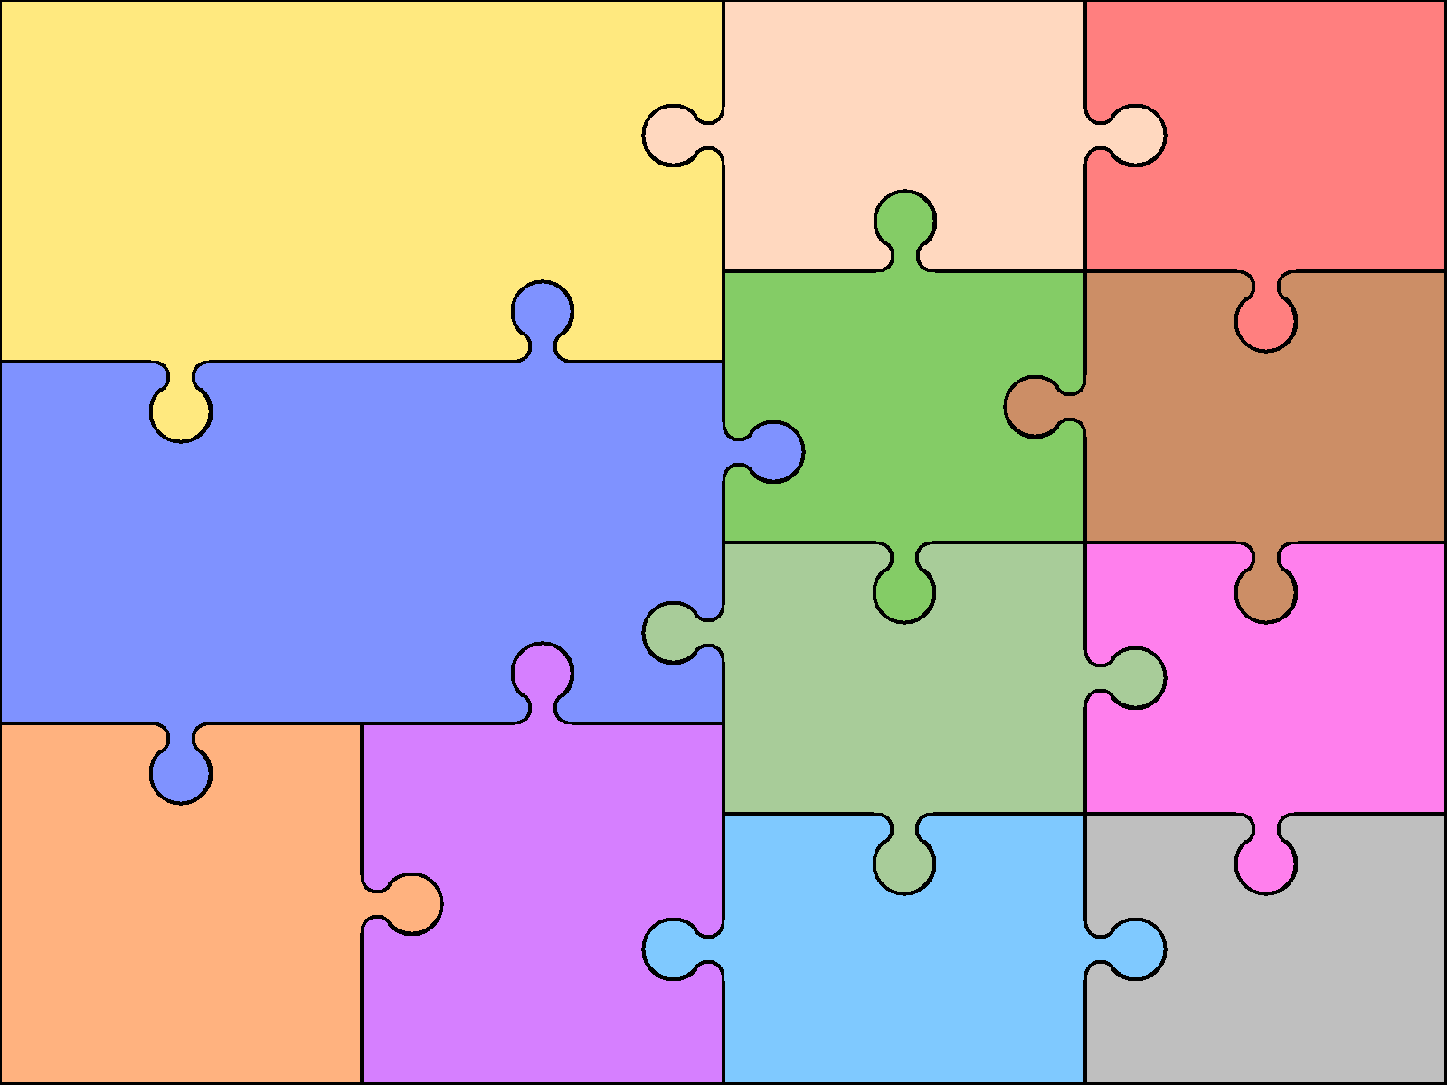  Reading  - Kensuke’s Kingdom  - Chosen novel in class  - Guided reading books | English  Writing  - Recount: Biograohy Class Artist Josh Bryan  - Novel as a theme- narrative  - Novel as a theme-balanced arguments |  | Grammar  - Adverbials  - Subject and object  - Active and passive  - Perpositions  - Types of sentences  - Revision  - Spellings | Art & Design  - Self portraits in the style of the artist Josh Bryan  - Camouflage in the natural world  - Daw and paint to experiment with camouflage  - Manipulate digital media | Computing  - Esafety  - Digital research
 |  |  |  | French  - Alphabet  - Days of the week  - Months of the year | PSHE and SMSC  - What does our family look like?  - New Beginnings  - Democracy
Mathematics
- Place Value
- Addition and Subtraction
- Multiplication and Division

 |  |  |  | Physical Education  - Dance (evolution of dance over time)  - OAA  History | Music  Religious Education  - Hinduism; What is God like?
Science  - Evolution and inheritance  - Living things and change  - Living things  - Animals and plants adapting to their environment |  | Geography  - World countries  - Using maps to focus on Europe, North and South America

