Curriculum Overview for Year 5/6 Eagles Autumn Term 1 (2018/2019) Geography
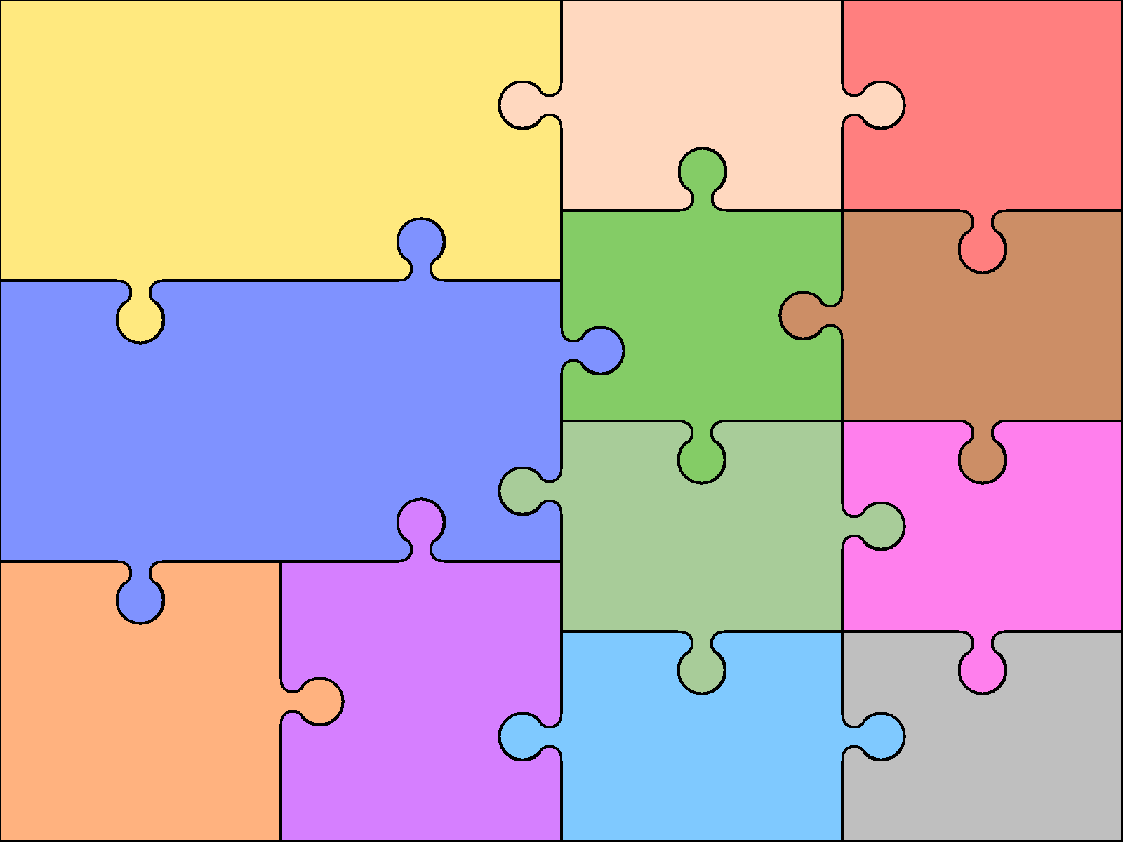  Reading  - Kensuke’s Kingdom  - Chosen novel in class  - Guided reading books | English  Writing  - Recount: Biograohy Class Artist: Vince Low  - Novel as a theme- narrative  - Novel as a theme-balanced arguments |  | Grammar  - Adverbials  - Subject and object  - Active and passive  - Noun phrases  - Modal verbs  - Prepositions  - Determiners  - Spellings  - Types of sentences  - clauses | - World maps  - Using maps to focus on Europe, North and South America  Art & Design  - Self portraits in the style of the artist Josh Bryan  - Camouflage in the natural world  - Daw and paint to experiment with camouflage  Manipulate digital media | Computing  - Esafety  - Digital research  PSHE and SMSC  - What does our family look like?  - New Beginnings  - Democracy
 |  |  |  | French  - The alphabet  - Days of the week  - Months of the year | Music and history will be covered in a different term.
Science  - Evolution and inheritance  - Living things and change  - Living things  - Animals and plants adapting to their environment |  |  | Mathematics  - Place Value  - Addition and Subtraction  - Multiplication and Division  Geography  - World countries  - Using maps to focus on Europe, North and South America
 |  |  |  | Physical Education  - OAA | Religious Education  Hinduism; What is God like?

