Dates for this coming term:
Doves’ Class Assembly ~ Tuesday 21st November 15:00-15:25
Owls’ Class Assembly ~ Tuesday 28th November 15:00-15:25
2nd Parent Forum ~ Monday 4th December. 18:00-19:00. So far topics to be discussed are our Mixed Age Classes and our Music provision. Please use the link to register your interest and a topic you would like to be discussed. https://docs.google.com/forms/d/e/1FAIpQLScU90ePbIA-n_yhpoPrfukebNL9eSKUYDeeyrvkK8ELSy1Y2Q/viewform
Friday 8th December ~14:30-15:30. Open afternoon to share how we carry out Guided Reading sessions in school.
Little Chicks’ and Ducklings’ Nativities ~ Tuesday 12th December at 09:30, 14:00 and Wednesday 13th December at 09:30
Years One and Two Christmas Productions ~ Thursday 14th December at 14:00, 18:00 and Friday 15th December at 09:30.
Christmas Lunch will take place on the 19th December.
Christmas Candlelit Carol Service ~ 19th December from 18:00 at Rossall Chapel.
Christmas Market ~ Thursday 21st December at 15:00 -17:00 in our large playground.
End of Term Friday 22nd December at 14:30.
Please keep looking at the dates section as we will be adding information.
Any amendments will be highlighted in red.
We have had yet another fabulous week that started for me and a few children from school on Sunday morning. I was very proud standing with all those that assembled around the cenotaph in Poulton for Remembrance Day.
Later on this week we were able to enjoy the successes of our dancers performing at The Preston Guild Hall with Miss Howarth and Miss Watmough. They have worked so hard and performed brilliantly on the night! Please go onto our website to see a video.
Mrs Harding also wanted to share the success of her maths’ workshop. She invited all the parents of children in the Lower KS2 to attend and learn about how we teach maths in school. She is holding these sessions on Thursdays after school and would welcome your attendance. Next week she is looking at addition.
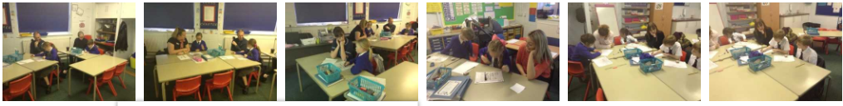
I cannot believe that already we are hearing festive tunes around school with rehearsals starting in our infants and whole school assemblies. Our Candlelit Carol Service will nearly be here, and we want it to be as fabulous as ever. We hope that you will support this event by sending your child to participate on the evening of the 19th. All families are welcome. We only ask that you use the link to register your interest to help us with accommodating us all.
The more the merrier and definitely the warmer it is!!!
https://docs.google.com/forms/d/e/1FAIpQLSdITf9XpA8ncNF7XPB6-apW6xTp1lCkYqE_YeLuWZ5gTh14zw/viewform
The Operation Christmas Child Appeal was wonderfully supported where Mrs Walsh was able to send 56 boxes full of gifts from our school. I know that these will really make a difference to children that are less fortunate than our own.
This week we have celebrated our star writers and mathematicians. A huge well done to:
Star Writers:
Georgia Hale, Daniel Pilling, Katie Workman, Sam Middleton, Ella Reader, Annabel Billington, Mamie Walker, Charlotte Wood, Tallulah Sorensen, Alex Haigh and Emily Stewart.

Star Mathematicians:
Carys Benson, Lucas Wilmot, Leo Yeung, Jessica Williams, Gracie Sykes, Cara Hey, Harry McLaughlin, Max Billington, James Shaw, Jacob Ashworth andJack Hodgin.

We are very excited to introduce you to a new member of staff who we will be welcoming to Carleton Green Community Primary School.
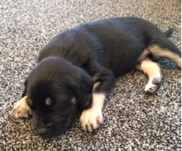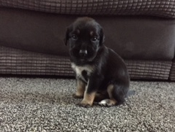

Romeo was born on 8th September 2017. He is a Border Collie Labrador who soon will begin his training to become a school dog and is set to become an integral part of our school community. He will shortly be beginning his first set of puppy classes and in time we plan to train him to become a fully qualified Pet Therapy Dog.
Below we have set out the benefits of a school dog, and tried to address concerns you may have. What are the benefits of having a school dog?
Numerous research studies have shown the benefits of therapy dogs in schools. Therapy dogs have been working in schools for the past 5 years across the UK. However, they have been commonplace in schools in the USA and Australia for many years.
Evidence indicates that benefits include:
- Cognitive – companionship with a dog stimulates memory, problem-solving and game-playing
- Social – a dog provides a positive mutual topic for discussion, encourages responsibility, wellbeing and focused interaction with others
- Emotional – a school dog improves self-esteem, acceptance from others and lifts mood, often provoking laughter and fun. Dogs can also teach compassion and respect for other living things as well as relieving anxiety.
- Physical – interaction with a furry friend reduces blood pressure, provides tactile stimulation, assists with pain management, gives motivation to move, walk and stimulates the senses
- Environmental – a dog in a school increases the sense of a family environment, with all of the above benefits continuing long after the school day is over. As you will be aware we already have a Pets As Therapy dog visiting us in school to overcome anxieties of dogs in the community.
- Reading to dogs has been proven to help children develop literacy skills and build confidence, through both the calming effect the dog’s presence has on children as well as the fact that a dog will listen to children read without being judgemental or critical. This comforting environment helps to nurture children’s enthusiasm for reading and provides them with the confidence to read aloud.

Our Governors think that this addition to our school will be a great form of support for our children and they are going to help me rigorously risk assess the situation annually.
Some concerns you might have:
- My child is allergic to dogs It is understandable that some of you may be concerned about possible allergic reactions to a school dog. However, Romeo will be subjected to the most thorough cleanliness and grooming regime. He will also only be allowed in situations with pupils who voluntarily wish to work with him. Your permission will of course be sought in advance of Romeo having access to, and working with, your child in school.
- Will Romeo be properly cared for? Romeo will be extremely well looked after. He will live with Mrs McGrath and her family and will come to school most days but will stay safely in the office until satisfactory training has been completed. He will then, in time, work in classes but will always be accompanied by a trained adult. He will undergo thorough and rigorous training (beginning with puppy classes) so will be extremely well-behaved. Romeo will be assessed by a Pets As Therapy Assessor before working with any children. Whilst Romeo is in school he will have access to a dog crate in the office spaces where he can ‘chill out’ during the day! This is where he will spend most of his time initially. Romeo will visit the vet regularly for all his injections as well as regular check-ups. If Romeo is unwell for any reason he will stay at home.
- My child is scared of dogs. Some children may have had upsetting experiences and thus have a fear of dogs (or another animal). Romeo will only be in contact with children whose parents have given their permission. However, Romeo’s training will help him to be calm and gentle around children; he is already showing signs of a very loving and gentle nature. Experience and research have shown that, with proper guidance and handling, children can learn to overcome their fear of animals and grow in respect and appreciation for them.
- The school has a ‘no dogs’ policy. Our school does have a ‘no dogs’ policy, however because Romeo is training to be a Pets As Therapy dog he will be allowed in school. He will be on a leash at all times when moving around the school property and will always be accompanied by a trained adult. Romeo will also be fully insured to carry out his role thus allowing him to be on the school site.
We hope you will join us in welcoming Romeo to the Carleton family and embrace all that he has to offer the school.
More information about his progress will be in future newsletters with details to seek your permission regarding contact with Romeo sent home soon.

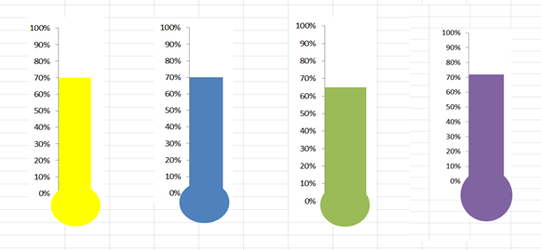
If you haven’t already please could you make your trip payments via parent pay or cheque?
Ducklings ~ £20 contribution per child
Parrots, Herons and Robins ~ £22 contribution per child
Kestrels, Doves and Owls ~ £24 contribution per child
Falcons, Hawks and Eagles ~ £30 contribution per child
https://www.parentpay.com/public/client/security/#/login or pay via a cheque.

Yellow Ducklings  95% with 1 late | Brown Ducklings  98% with 2 lates | Parrots  92% with 0 lates
Herons  95% with 0 lates | Robins  92% with 3 lates | Owls  98% with 3 lates
Kestrels  98% with 0 lates | Doves  96% with 2 lates | Falcons  98% with 1 late
Hawks  97% with 3 lates | Eagles  99% with 2 lates | Well done to those for making it to school every day on time!

Please do not use the carpark at the front of our school. This is for the staff of Carleton Green only and Must not be used for dropping off or picking up purposes.
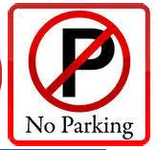

Thank you for all your continued support for all that takes place inside and beyond school.

Susan McGrath
Headteacher.

