Call 01252 547896

Book banding information and suggestions for supporting your child with reading at each stage
Book bands are indicated on books by the sticker colour on the side. The colour of the spine varies between publishers. Most of our reading scheme books come from Oxford Reading Tree. The book banding system is used nationwide and any scheme can fit into it. The picture below shows the book bands progression and approximate age range.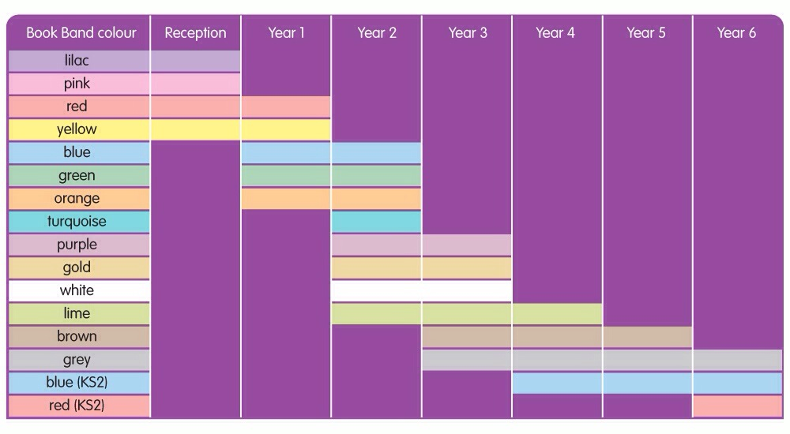

Book Bands are intended to support each child as a reader, and enable teachers to carefully check what each child can do and what their next steps are. They should not be used to make comparisons between children; nor is it a race to ‘get to the end’.
Children should read at home as frequently as possible, and the adult to whom they read should sign the reading record each time, a few pages each night is sufficient. We do not expect children to read a full book each night!
We all know how vitally important it is for children to read and be read to at home. Equally, we know how difficult it can be to know how to help. Below, you will find ideas for supporting your child’s reading, whatever Book Band they are choosing from.
Things to Remember
- Do try to hear your child read every day or read to them.
- Little and often is more beneficial than a long session once a week.
- Think about how long you are reading for – the amount of reading time shouldn’t exceed your child’s span of attention.
- Pick your timing carefully – it’s best not to embark on a reading session when your child is tired.
- Every child is an individual – try not to compare your child’s progress with other children or with brothers and sisters.
“Parents can instil a love of reading long before a child goes to school and deepen that love of reading as the child grows up.”
Lilac Band
Wordless Books
Wordless books tell a story through pictures alone. They help children to develop speaking and listening skills through creating and telling stories.
Your child is just beginning to discover the excitement of books. Although these books have no words, they are an important introduction to reading. Please encourage your child to:
- Look at the pages in order, and talk about what is happening on the left hand page before the right hand page.
- Talk about what is happening on each page, rather than just talking about what they see in each picture.
- Tell you who or what the book is about.

Pink Band
Your child is beginning to learn to read. As they read, please help them to:
- Pink level is the very first level of reading books which has words. The number of words increases slightly as your child progresses through the reading level.
- Read the words carefully. Ask your child to sound out and blend only the words they can’t read yet, not every word. Eventually almost all words will become part of your child’s ‘sight memory’, and they won’t have to sound out at all.
- On second and third readings of the book, encourage them to read with more pace and with less focus on sounding out the letters in each word.
- Make a story out of a whole book, rather than focusing just on what is happening on each page.
- Tell you about something that happened in the book, or about something they found out in the book.
- Tell your child ‘tricky’ words like the (where the sounds they have learnt do not correspond to the word directly) and see if they can remember that word the next time they see it.

Red Band
All bands aim to consolidate learning from previous bands. Red level books have a slightly increased number of words, pages, along with slightly more complex story lines.
Your child is beginning to learn how to read. As they read, please help them to:
- Read the words carefully. Most of the words can be recognised or sounded out. Ask your child to sound out and blend only the words they can’t read yet, not every word. Eventually almost all words will become part of your child’s ‘sight memory’, and they won’t have to sound out at all.
- On second and third readings of the book, encourage them to read with more pace and with less focus on sounding out the letters in each word.
- Make a story out of a whole book, rather than focusing just on what is happening on each page.
- Tell you about something that happened in the book, or about something they found out in the book.

Yellow Band
Your child is now beginning to read with more confidence. As they read aloud, you can help them by:
- Yellow books require some inferencing skills from the reader – reading ‘between the lines’ – and have more variation in sentence structure.
- Giving them time to sound out words they don’t know. If they still struggle, encourage them to try sounding out the whole word first, rather than guessing from the pictures or from the first letter.
- Giving them time to recognise and correct their own mistakes.
- Asking them to talk about what’s happening in the book, encouraging them to make links to events on previous pages.

Blue Band
Blue books have a slightly increased number of words and some variation in sentence beginnings. They may use different punctuation. The story lines are more complex, including more than one event, and the stories are less dependent on picture cues.
Your child is now developing into a more confident reader. Encourage them to select from books at the library or bookshop as well as those from school. As they read, you can help by encouraging them to:
- Sound out quickly – and silently – inside their heads, if they need to sound out words.
- Look at the punctuation marks. You may want to model how to read a page of writing, paying attention to punctuation, such as full-stops and question marks.
- Tell you about what the characters in the story are doing and why they are acting in that way.
- Show you how they can find particular things that interest them in non-fiction books.

Green Band
The number of words increases slightly in Green level books. Stories have a wider variety of characters and events which develop over a number of pages. Sentences may include lists of things or actions, and adverbs are used frequently to begin sentences.
Your child is now developing into a more confident reader. Encourage them to select from books at the library or bookshop as well as those from school. As they read, you can help by encouraging them to:
- Sound out quickly – and silently – inside their heads, if they need to sound out words.
- Look at the punctuation marks. You may want to model how to read a page of writing, paying attention to punctuation, such as full-stops and question marks.
- Tell you about what the characters in the story are doing and why they are acting in that way.
Show you how they can find particular things that interest them in non-fiction books.

Orange Band
- Your child is now beginning to read with more independence. They should be feeling more confident and will rarely need to sound out words. You can help them by:
- In Orange books, the page count increases to challenge and encourage reading stamina. There is an increased use of dialogue to encourage reading with expression. Orange books introduce some complex sentences (use of ‘if’, ‘so’ and ‘because’) and include italics to show emphasis. Slightly more literary language is used. Children are increasingly encouraged to infer meaning from the text in order to gain full enjoyment from the story.
- Listening to them when they read aloud. If they make mistakes, but they keep the sense of the text, don’t interrupt. You can revisit that page at the end of the session to check certain words.
- Reminding them of useful strategies if they can’t read a word, for example:
  - Sounding the word out silently, under their breath
  - Dividing a longer word into syllables, or looking at the word without an –ing or an –ed ending
  - Don’t allow them to worry about a word. Tell them what it says and revisit the word once you have completed the book.
- Encouraging use of expression, especially for character-speech in fiction books. You may wish to model reading some pages aloud for your child to copy.
- Talking about how characters are feeling.

Turquoise
Turquoise books include an increasing range of adjectives and more descriptive verbs to replace ‘said’. There is an increased proportion of space allocated to print rather than pictures.
Books include words chosen for appropriateness and impact rather than decodability, with more extended descriptions. Paragraphs begin to develop and more unusual and challenging vocabulary is included.
Your child is now beginning to read with more independence and their books are getting longer. You can help them by:
- Encouraging them to read some pages silently, inside their heads.
- Listening to some pages read aloud, encouraging the use of expression and paying attention to punctuation marks.
- Talking about how events in the book relate to each other and helping your child to understand how the story builds up in a longer book.
- Asking them to tell you about interesting things they found out and showing you where the information is in the book.

Purple
Purple books include an increased proportion of longer sentences, with a more challenging vocabulary. Some Purple books have short chapters to challenge and encourage reading stamina. They include longer and more complex sentences with the inclusion of complex (i.e. ‘when’) and simple (i.e. ‘and’) conjunctions. Story features such as plot, character and setting are developed in more detail, and the text in the non-fiction books is presented in a variety of ways.
Your child is now beginning to read with more independence and their books are getting longer. You can help them by:
- Encouraging them to read some pages silently, inside their heads.
- Listening to some pages read aloud, encouraging the use of expression and paying attention to punctuation marks.
- Talking about how events in the book relate to each other and helping your child to understand how the story builds up in a longer book.
- Asking them to tell you about interesting things they found out and showing you where the information is in the book.

Gold
Children reading at this level are confident independent readers who can tackle increasingly complex language, story structures and text layout.

Gold books include more sophisticated and challenging vocabulary, including word play and the introduction of figurative language (e.g. similes and metaphors). Some Gold books have longer chapters for more sustained reading. Your child is now reading longer books with fewer illustrations, so they continue to need your help to ensure they are getting the full meaning and enjoyment from the text. They may prefer to read one chapter or section at a time, rather than reading the whole book in one session. You can support them by:

- Asking them to read some pages of the book aloud to you so that you can enjoy hearing them reading with expression and pace.
- Asking them to find parts of the text which describe a character or place and talking about the words used in the description.
- Asking for regular updates as to what is happening in the book, so that you know how the different chapters or sections link.
- Talking about how much they enjoy a book, or a type of book. Encourage them to look for more books of the type they enjoy.

In White books there is a more sophisticated use of narrative voice. Clauses in longer sentences are separated by commas to encourage developing intonation. Some books have longer chapters for more sustained reading.
The stories included at White level encourage children to empathise with the characters and consider why they behave as they do, and how they change during the course of the story. The non-fiction books are divided into sections that require more sustained reading and there is increased challenge in the layout of the information.
Your child is now reading longer books with fewer illustrations, so they continue to need your help to ensure they are getting the full meaning and enjoyment from the text. They may prefer to read one chapter or section at a time, rather than reading the whole book in one session. You can support them by:
- Asking them to read some pages of the book aloud to you so that you can enjoy hearing them reading with expression and pace.
- Asking them to find parts of the text which describe a character or place and talking about the words used in the description.
- Asking for regular updates as to what is happening in the book, so that you know how the different chapters or sections link.
- Talking about how much they enjoy a book, or a type of book. Encourage them to look for more books of the type they enjoy.

Lime
Lime books include a wider range of writing styles and an increased variation in sentence structure. Children reading Lime books will be able to understand more sophisticated word play and puns.
Although your child is now taking off as a reader, it is still important that you read with them and talk to them about their reading. This is a great opportunity to share with them your love of reading. You can support them by:
- Asking them to read aloud some parts of the text which they particularly enjoy. Talk about how the author made them so enjoyable.
- Talk about how characters develop or how they react to different people, places or events.
- Asking for regular updates as to what is happening in the book, so that you know how the different chapters or sections link.
- Reading the book, yourself so that you can talk together about the smaller details of the book.

Brown
Children reading Brown books are able to:
- interpret more sophisticated word-play and puns
- distinguish the narrator’s voice in a fiction story from the characters’ voices through figurative, idiomatic and literary language
- understand a story that is told through dialogue and action to ‘show’ instead of ‘tell’ the plot
Your child may well not want to read aloud to you anymore because they probably enjoy silent reading more. This is fine as long as your child continues to read actively and not just pass their eyes over the words. You can help them by:
- Continuing to make a time available for regular quiet reading sessions, and reading your book while your child reads.
- Establishing an expectation of a conversation at the end of each reading session: can they tell you what’s happening in their book?
- Ask questions which make your child go back to the book to find answers. Support your child as they develop skills in skimming and scanning to find the information to answer your question.
- Continuing to read aloud to your child at bedtime. This shows them the importance you place on reading as well as developing their language, vocabulary and love of story.

Grey
Children reading Grey books should be able to:
- explain a character’s motivations
- discuss the points of view of the character and the narrator
- better understand a range of narration styles
- your child may well not want to read aloud to you anymore because they probably enjoy silent reading more. This is fine as long as your child continues to read actively and not just pass their eyes over the words. You can help them by:
- continuing to make a time available for regular quiet reading sessions, and reading your book while your child reads.
- Establishing an expectation of a conversation at the end of each reading session: can they tell you what’s happening in their book?
- Ask questions which make your child go back to the book to find answers. Support your child as they develop skills in skimming and scanning to find the information to answer your question.
- Continuing to read aloud to your child at bedtime. This shows them the importance you place on reading as well as developing their language, vocabulary and love of story.

Dark Blue
Children reading Dark Blue books will be able to gather information from more than one place in the text and use inference based on what is shown rather than being told. This allows for greater complexity in building character and setting.
The books at this level are written in a much more subtle way than in previous levels which means that it is important that the reader is fully engaged with the process of reading and alert to the language and vocabulary the writer is using.
You can help them by:
- continuing to make a time available for regular quiet reading sessions, and reading your book while your child reads.
- Before a reading session, ask your child to find and note down some particular information. It could relate to the plot or it could be something like: a really good descriptive passage; three words which are adventurous; two words you want to use in your next piece of writing; an example of something typical a character does or says; how one character’s reaction to another shows their relationship … There are lots of questions you can ask which don’t mean you have to know the book yourself, but just serve to alert your child to its possibilities.

Dark Red
Children reading Dark Red books are beginning to recognise how layers of meaning allow for the build-up of humour or tension and are able to discuss how the author has achieved the effects.
The books at this level are written in a much more subtle way than in previous levels which means that it is important that the reader is fully engaged with the process of reading and alert to the language and vocabulary the writer is using. This level is more advanced than many books that are sold to adults but these stories are not intended to be just ‘leisure reads’. Although your child should enjoy them, the books need the reader to be fully alert and willing to learn.
You can help them by:
- continuing to make a time available for regular quiet reading sessions, and reading your book while your child reads.
- Before a reading session, ask your child to find and note down some particular information. It could relate to the plot or it could be something like: a really good descriptive passage; three words which are adventurous; two words you want to use in your next piece of writing; an example of something typical a character does or says; how one character’s reaction to another shows their relationship … There are lots of questions you can ask which don’t mean you have to know the book yourself, but just serve to alert your child to its possibilities.

