Our News
Thank you to all of the helpers that were able to help us on our trip to Clitheroe Castle.
Thank you to all of the parents who attended our Parents’ Evenings. It was lovely to be able to share with you all of the progress the children are making and to share with you their next steps of learning. It’s hard to believe that we are half way through the year already!
This week were lucky to be able to celebrate Shrove Tuesday together in school. We read the story of The Runaway Pancake and helped to make and eat our own pancakes. They were yummy!
We were very lucky to enhance our Terrific Transport topic this week when Freddie from Ducklings brought his mud bike in to talk to us about. The children were very interested and enjoyed asking lots of questions. Thank you Freddie and to his daddy for bringing it in. This week we look forward to a visit from Abigail and Jimmy’s uncle, whose job is a train driver. The Ducklings also started their Road Safety learning this week and were all very sensible and listened brilliantly to what they were asked to do. Well done!
Thank you to all of the Ducklings who have returned their news writing books. We really do find that this little bit of writing each week brings their writing on so much. Any questions about it, just ask one of us.
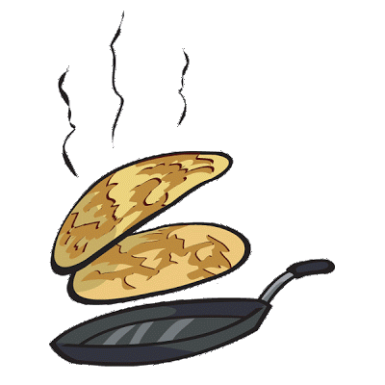
Our Learning
We have been looking at different photographs of, researching different types of transport and talking about forms of transport that we have travelled on or seen. We have enjoyed reading the sing-along story, ‘The Journey Home from Grandpa’s.’ We have been on welly walks to look for signs of the new season – spring and sketching what we could see, hear, smell and touch. We have enjoyed creating resources for our different role play areas and have enjoyed helping to make a train to sit and read in in our reading area. In the construction area the children have enjoyed creating and building their own vehicles using a variety of construction materials.

Little Chicks
We have been…
- Making marks with the wheels of different vehicles
- Comparing lines of traffic, estimating how many are there and saying if they are the same amount or not
- To move toy cars around different 2D shapes to help learn them and recognise their features, naming them and looking for them in their environment
- Making vehicle pictures with the 2D shapes. Come in and look at them!
- Looking at objects that begin with ‘p’

Ducklings
We have been…
- Investigating which vehicle can travel the furthest distance and using different distance vocabulary
- Exploring the different properties of 2D and 3D shapes and sorting them in different ways, such as those that can roll, those that have straight edges
- Creating our own 2D shape vehicle pictures
- Writing our own ‘Journey Home from Grandpa’s’ stories
- Carrying out our own traffic surveys on the traffic that passes our school and completing tally charts
- In Phonics we have been learning the phonemes oa, oo, ar, or, ur, ow and oi and practising handwriting them cursively and blending to read words with them in

What we will be learning next
We will be reading more transport themed stories – The Train Ride and The Bus is for Us! We hope to have visitors from the fire service, Blackpool Transport and the police with their vehicles!
- Creating our own junk model vehicles
- Observing more of the changes around us in spring
- Creating our own obstacle courses outside, to move around in different ways
- Little Chicks will be moving on to the letter ‘i,’ making name trains and finding out more about 3D shapes
- Ducklings will be learning about length and distance and learning the new phonemes – ear, air and ure

Ducklings – Preparing for Year 1
As part of our gradual transition into Year 1 we will begin this important process with a slight change to our daily routine, beginning next week on Monday 18th March. We want the children to come in by themselves and say goodbye to you at the doors. They are all able to unpack and organise their bags now and we are all there to help them, should they need it. Thank you for your help with this and remember we are still there to speak to you if you should you need to. Just ask!
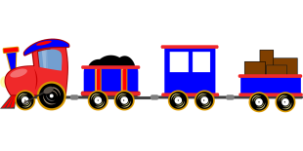

Reminders
BLOG
Have a look together at the blog on the school website to find out more about learning in school each day. A homework activity could be to think of a comment together and for the grown up to add it for you! There are lots of pictures on the blog from pancake day.

All About Me booklets
It’s not too late to return any of these to school if you still haven’t returned it.

Needed
Please send in any junk materials for model making. We particularly need egg boxes and cardboard cylinders.
We are also in need of an old land line style phone for our home corner, if anyone has an old one lying around.

How can you help at home?
Little Chicks
Look for 2D and 3D shapes whilst out and about
Look at different transport when you are out and about

Ducklings
Talk for Mathematics
Spot different 2D and 3D shapes around your home
Compare and order different objects according to their length or height – socks, scarves, teddies, breadsticks, etc.
Use non-standard measures to measure the length of something – for e.g. my bed is 10 footsteps long or as wide as 5 books.
www.ictgames.com/numeracy
www.topmarks.co.uk

Talk for Reading and Writing
Read and talk about your book every night.
Practise the phonics flashcards and tricky word games.
Write sentences with the tricky words in or look for them in your reading books.
Write in your news book.
www.phonicsplay.co.uk
www.ictgames.com/literacy
www.phonicsbloom.co.uk
www.oxfordowl.co.uk

Talk for topic
Explain to your grown up all about what we have been learning in road safety.
Make a junk model vehicle.
Complete some of the challenges on the home school learning sheets sent home.
Research some facts and make a fact file about a particular vehicle.

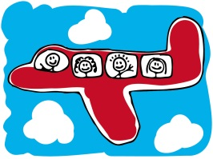

Dates for your diary:
Tuesday 26th March – Yellow Ducklings Class Assembly 3pm – All welcome
Friday 29th March - Mothers’ Day PTFA afternoon 1.30pm, 2.30pm or 3.30pm
Thursday 4thApril - Open afternoon 2.30-3.30pm

Our next newsletter will be on Friday 22nd March and will give details about all the fun activities we have planned for the next two weeks.
Any questions please don’t hesitate to ring, email or come and see us.
Staff email:
Mrs Lees s.lees@carletongreen.lancs.sch.uk
Mrs Catterall m.catterall@carletongreen.lancs.sch.uk
Mrs Stock j.stock@carletongreen.lancs.sch.uk

