**WW2 Recipes**

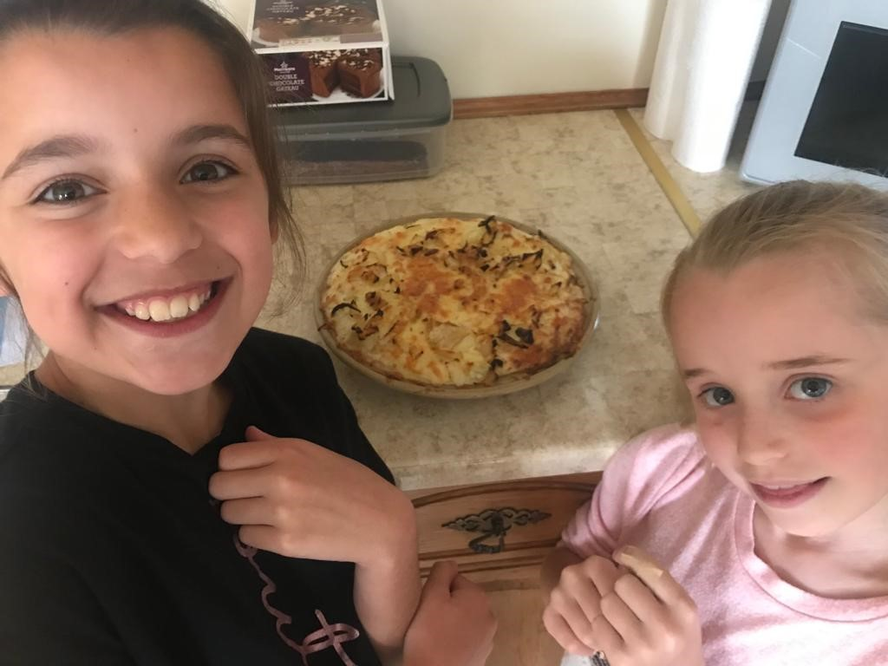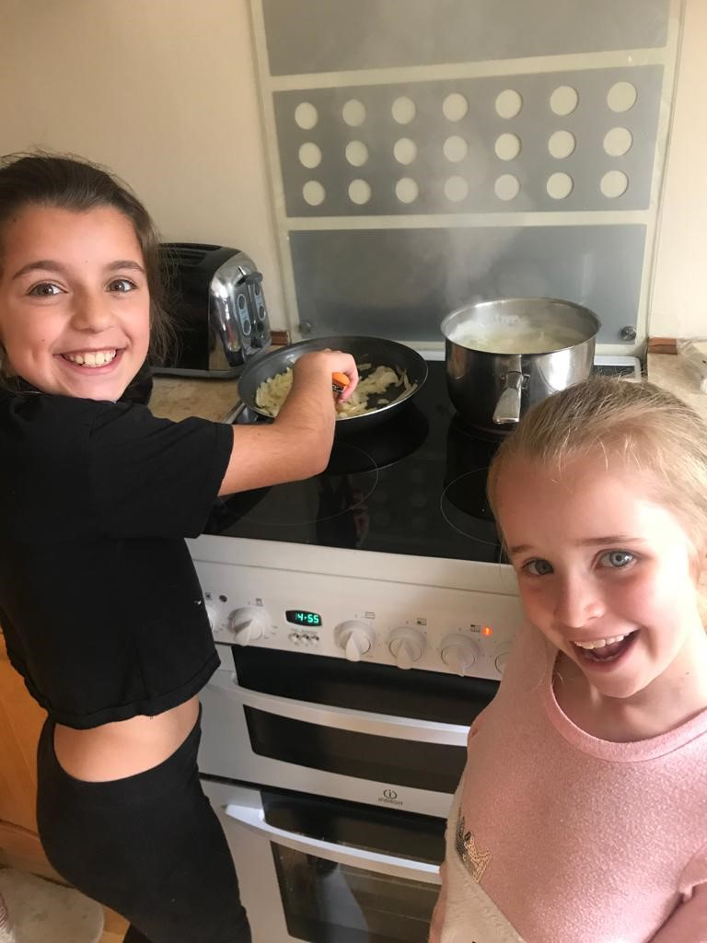

This is us about to try the pie it was really nice and then we made the cottage pie.

This is me making the cheese, potato and onion pie. I was cooking the onion in this picture.

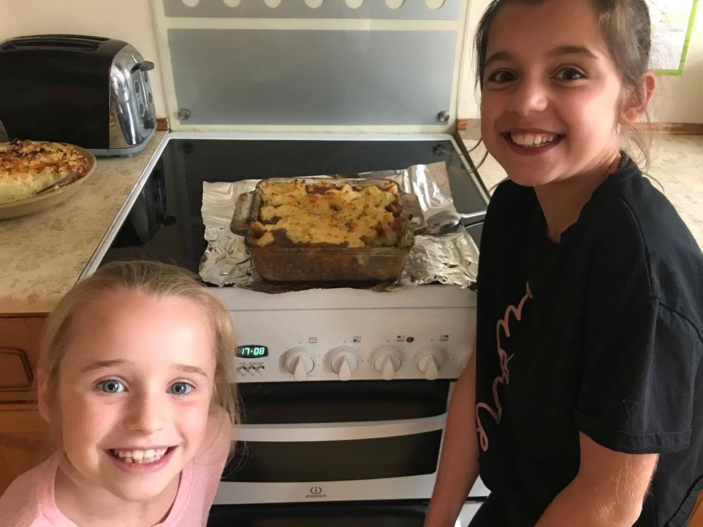

The cottage pie was my favourite, it was really good and we had it for tea.