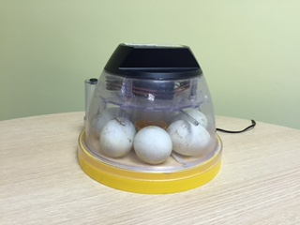
Our baby ducklings have safely arrived with their hatching starting on the Tuesday and ending with Mr Jones carefully peeling the shell off the last baby duck on Thursday. They have provided us with much awe and wonder and we have all found it to be a wonderful experience. We will be very sad to wave them farewell on Thursday.
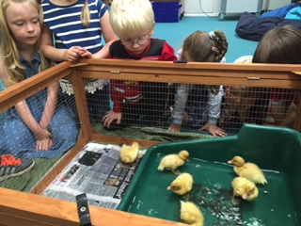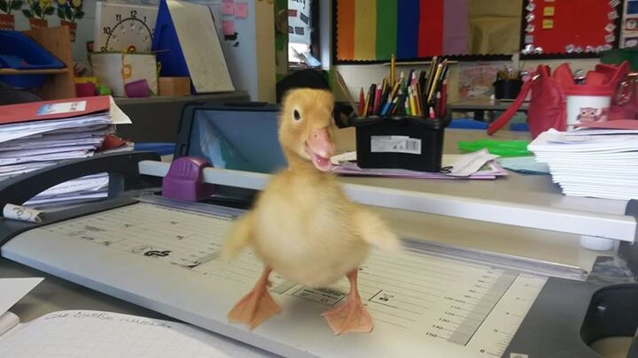
Thank you for the fabulous turn out for our annual summer fair despite the rain clouds endeavouring to spoil our efforts. It was a lovely evening and I am still awaiting to hear about how much it has raised. Thank you also to all those that helped and to the staff that stayed after a long week to support the event.


Kids Love Books is our attempt to discover the UK's favourite children's books–as voted for by children themselves. With Kids Love Books we hope to encourage children across the country to talk about and share their favourite reads. We then plan to publish the results on our site to help children and adults alike discover great books that they will enjoy.
Parents and teachers can take part by voting on behalf of their child or pupil(s) using the voting form on this page (please see below). Your child or pupil(s) school will then be entered into our prize draw to be in with a chance of winning our main prize of 30 Kindle E-readers and a £5,000 Amazon.co.uk Gift Card. Two runner-up schools will each win a £2,000 Amazon.co.uk Gift Card. The winning schools will be selected at random from all entries.

1st July ~ Got to Dance competition. Thank you to all the children that auditioned.
2nd July ~ Voice and Musician of the Year competition. 15:45
Week beginning 6th July ~ Year Six Camp 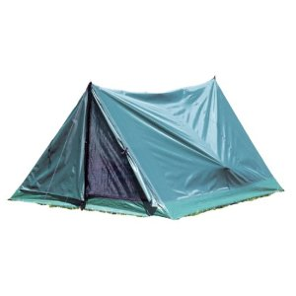with Mrs McGrath, Mrs Harding, Mrs Crooks, Mr Boyd, Miss Howarth & Mr Jones
Tuesday 14th July – End of Year Reports to go home with an annual parent and pupil questionnaire.
Wednesday 15th July – Meet the Teacher Evening and drop in for End of Year Reports.
Week beginning 20th July ~ Leavers Events – Awards Evening/Leavers Disco and BBQ for Year 6 pupils and parents, End of year production with year 5 & 6 pupils, End of term Assembly.
22nd July ~ School closes at 14:30 for the summer holidays.
Fleetwood Town will be running a holiday club at school for three weeks during the summer. Leaflets will be sent home in the near future. The club will start the week commencing 27th July and will run on alternate weeks.
Friends of the Jean Stansfield Memorial Park in Poulton are holding a music festival called 'The Big Gig' in the park on Sunday 12th July. There will be live music throughout the day, including performances from The Deadbeats, Poulton People's Choir, The Keytars, Ark, Ian Hooper, Solid States and many more, as well as The Young New Talent Award showcase for under 16's sponsored by Lloyds BMW. There will also be a mini fair, refreshments and fundraising for new play equipment on the day.
It is advertised to be a fantastic family day where the whole community can come together through music, at the same time as supporting the local park.

